HP 5071A Cesium tube retrofit March 2017

Hi,
Thought I'd share my results of the installation into an HP 5071A of 5061A/B "mini" tubes. (What I call the "mini" is the tube you find in some 5061A/B that is smaller in diameter than the original tubes. It's easily recognized by the black plastic fittings installed to make up the diameter so the tube clamps will hold onto the tube.) The high performance units are prefix 3112A and the standard units are prefix 3232A.
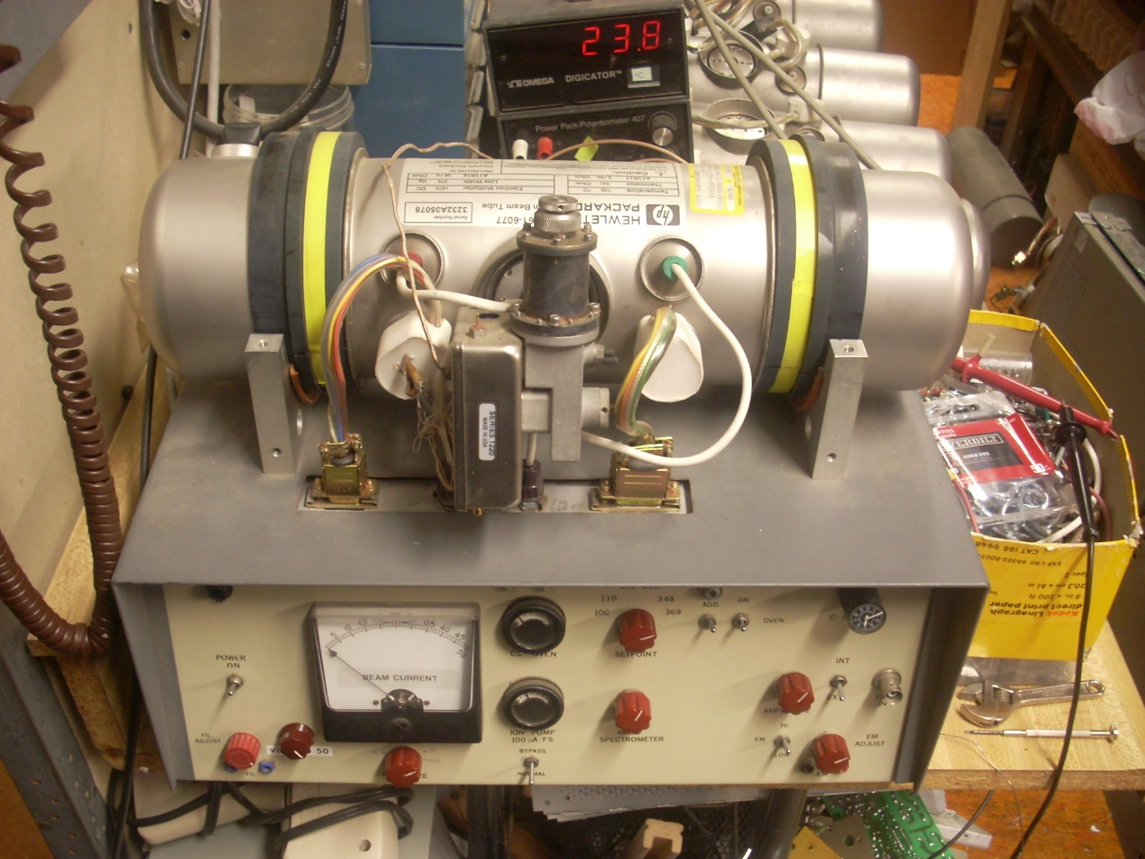
“Mini” tube in Cesium tube test set, note black plastic fittings

It looks like that after they changed over to 5071A tube production they used 5071A tubes with slight changes to provide replacement "mini" tubes for the 5061A/B. This can also be inferred by the dual 5061A/B-5071A mounting patterns on both tubes microwave input flange.

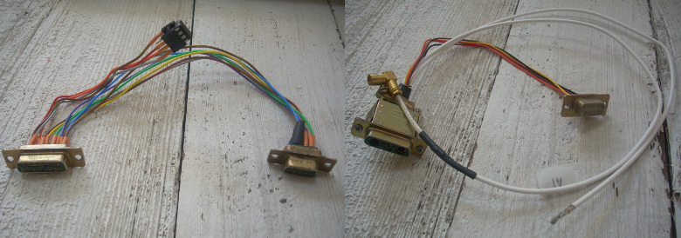
“Mini” to 5071A adaptor cables

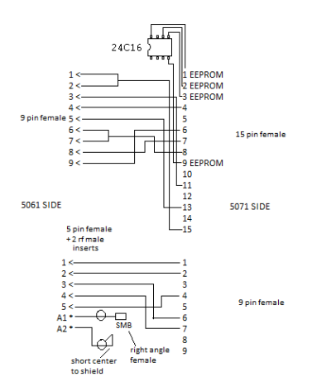
Adaptor cables schematic

First I fabricated two adaptor cables to convert between the 5071A pinout and the 5061 pinout, and to hold the EEPROM. Also before removing the dead 5071A tube I let the Cesium oven come up to temperature, powered down, rapidly disconnected the tubes cable, and "Ohmed" out the hot thermistor. This let me know what thermistor value the EEPROM contained.
Then I removed the EEPROM from the dead tube (it is inside the 15 pin connector shell) and installed it into the adaptor cable. ( An 8 pin DIP socket was used )
Looking at the value marked on the “mini” tubes labels I picked a good "mini" tube that had a thermistor value very close to the measured value. From what I have seen the high performance tubes will have around 350 Ohms. The Standard tubes have a much higher thermistor value of between 500 and 950 Ohms. These values hold for the "mini" and the 5071A tubes.
Removed the black plastic fittings and installed the "mini" tube, the adaptor cables, and the Waveguide adaptor from the dead tube. Powered up the 5071A and it went through its startup sequence normally. After letting it warm up a bit I then ran the "profiling program" and the 5071A passed all three tests. Then I measured the Allan Deviation against an active Maser and it met the factory specs easily. This picture shows the install. The wires and connectors are not “stuffed” in yet but have plenty of room to do so and allow the top cover to be replaced! This first one was a high performance tube.
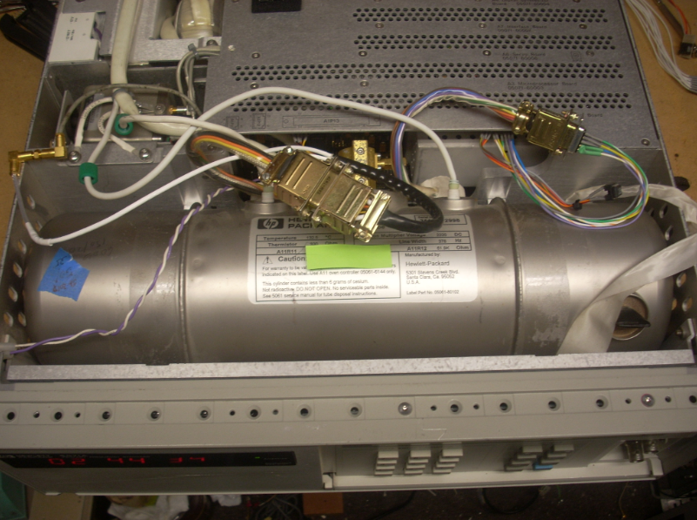
“mini” tube installed into a 5071A
I first did all this over 4 years ago (mentioned here: https://www.febo.com/pipermail/time-nuts/2012-October/070881.html) and have just returned to the project. I have installed three high performance and two standard "mini" into other 5071A units that had dead tubes and now they operate normally and meet factory specs!
Actually one of the high performance tubes falls just short of the specs. (It read 8.64X10-13th at 100 Sec vice the spec of 8.5X10-13.) I suspect that one of the other parameters in the EEPROM is not quite optimal. My guess is the mass spectrometer voltage is slightly off. Still even so it’s well worth resurrecting a dead 5071A!
There is some circuitry under the potting of the tubes headers. There is probably a small difference in that area between the two types of tubes. I’ve got a dead tube of each type side by side that I’m removing the potting from just to see!
On one of the 5071A with a high performance "mini" tube I then installed an EEPROM from a standard tube. The unit then met the Allan Deviation of a Standard tube. This would allow using the unit at the lower standard tube temperature to extend its life, and swapping EEPROMs if you want to return to High Performance!
I also installed an EEPROM from a high performance tube into a unit with a standard tube. This unit then met the Allan Deviation of a high performance unit! From what I can tell there is no internal difference between the high performance and standard “mini” or the 5071A tubes. Made the assembly line easier! The earlier large diameter HP tubes had quite different copper cavity designs. The “mini” high performance tube does still have the degaussing leads.
One other “just for the heck of it” test was to raise the oven temp from 130 C to 145 C and run the stability test again. The stability did increase but not by any significant amount.
Standard tubes run at 100 to 106 degrees C and the high performance at around 130 degrees C.
You can measure the ‘Mini” tubes oven temperature by attaching a temp meter to the thermocouple wires protruding from the potting. If the EEPROM you selected does not quite get the tube up to the proper temperature you can install a small value 1% resistor into the wire from pin 9 to pin 6 of the top adaptor cable. The more resistance the higher the oven temperature.
After salvaging the EEPROMS it’s time to cut up and dispose of my dead 5071A tubes. It’s nice they finally served a purpose!
Hope you find this interesting!!??
Cheers,
Corby Dawson

