THE “SUPER” HP5065A (Or maybe the HP 5065B?)

I consider the HP 5065A to be the last great laboratory grade Rubidium standard. Its design flowed out of the Varian 4700 and R20 standards. HP of course did its 1968 mentality best to improve upon them. And they really succeeded! The modern age Smaller/cheaper/lower power mantra and the telecomm market totally eliminated the incentive for a Company to design a replacement of the same quality.
I have worked with the HP 5065A for decades but around 8 years ago I started seriously evaluating all the design details of the HP5065A Rubidium frequency standard with the goal of improving the short term stability performance.
Over the years the stabilities of a really good unit became apparent. (Note that they beat the factory spec. by a fair amount.)
1Sec 1.0X1-12th 10Sec 4.0X10-13th 100Sec 1.0X10-13th
(Reference my post at time-nuts)
http://www.febo.com/pipermail/time-nuts/2013-January/073479.html
After a few years I could almost always, through a variety of “tweaks, achieve close to that performance on the units I serviced.
Of course being a good little time-nut I wanted more!
Many years back I had tried an optical filter to eliminate the visible portion of the lamp spectrum, the logic being that the required 780nm line is in the IR range and barely visible if at all, so anything you can see is interference. Trying this failed to provide any improvement and I gave up on the idea!
Then I found a reference that gave a bit more insight into the interfering spectrum idea!
http://tycho.usno.navy.mil/ptti/ptti2002/paper18.pdf
They use a low-pass (referenced to wavelength) filter and eliminate any light at wavelengths longer than 800nm or so. (This for a particular gas mixture) I have since found references to this method being used in some commercial units.
So back to the 5065A! I’m an empirical kind of guy so I procured a few narrowband 780nm band-pass filters of various widths and tried several schemes for mounting them on the output of the lamp. After deciding on the best arraignment the selected filter was installed and a few quick measurements made.
The shot-noise out of the photocell dropped from 180mv P-P to 80mv P-P! The DC photo current dropped from 72 to 22 uA. This looked promising. (By the way the front panel photo I reading also drops proportionally down to around 10 or so.)
After a bit of optimizing the following results were obtained. (Of particular interest to me was the improvement at 1 Sec!)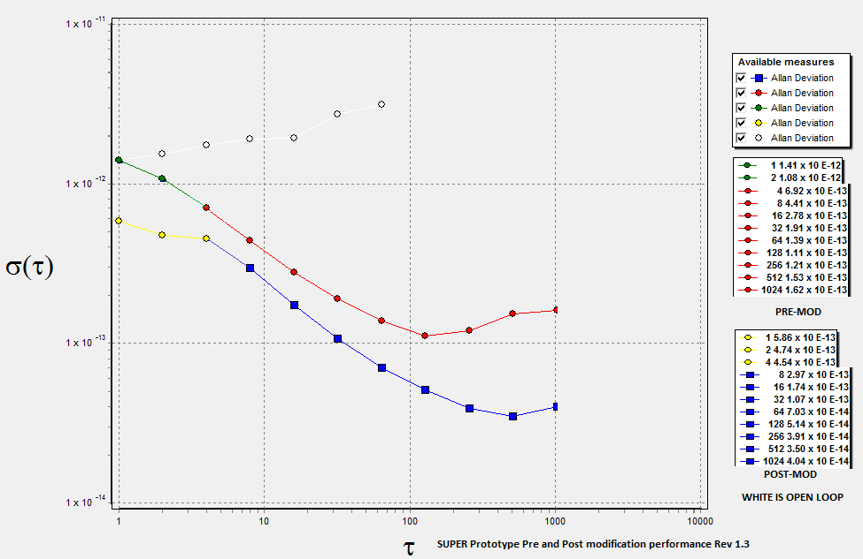
This plot shows the pre-mod versus the post-mod stability of the prototype unit as well as the free running or open loop stability of its 10811 Quartz oscillator. The Prototype was evaluated against an Active Maser here, an Active Maser at Tom Van Baak’s, and a Passive Maser at another site.

Three more units were “Supered” as a “sanity-check”, and the combined before/after plots are shown. They were evaluated against Various Active and Passive Masers and an Oscilloquartz 8607 BVA option 8.

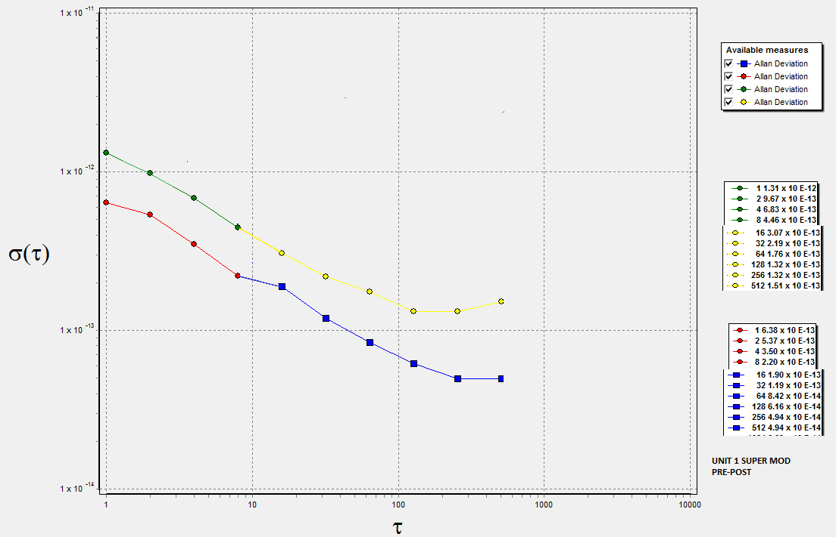
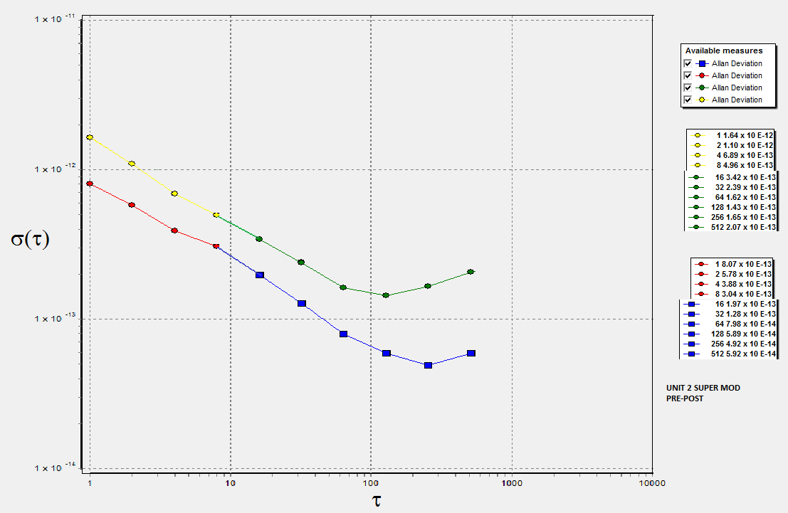

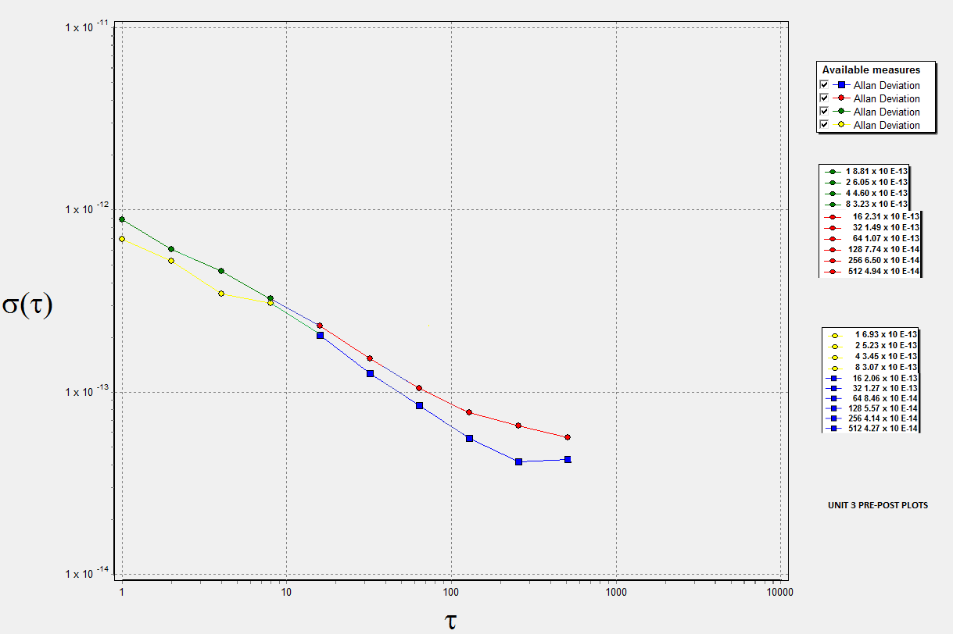
Unit three had amazing pre-mod performance! It was better that any unit I have ever seen! A “good” performing 5065A normally is comparable to the pre-mod plots of the prototype and units 1 & 2. (This is out of a sample of over 50 5065A units.)
Unit 3 achieved the same post-mod short term stability levels but the pre-post difference was less than the 3 previous ones.

One final plot compares the prototypes performance and a Passive Masers performance against that of an active Maser. (Courtesy of Tom Van Baak.) Pretty amazing!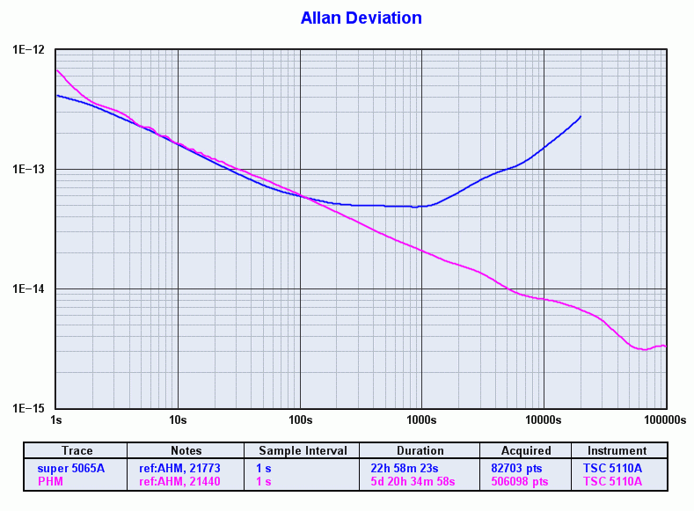
I have not found a documented performance for a rubidium that does this good!
Not bad for the marriage of a 1968 vintage design and a modern optical filter!
The 5065A being very “take-apart-able” makes this mod easy to install. Trying it on one of the modern minis might be a problem! Also these results were with units that have the late series A3 module installed. I’m not sure yet if the older A3 modules will provide the SUPER performance, so far they have not. Also lamp quality is essential to reach these levels. All 5065A lamps are not equal!
I’d like to thank some fellow time-nuts who generously contributed measurement time and hardware so that these results could carry some weight!
Tom Van Baak, John Ackerman, John Miles, and Jeff Parker
There are a few more who helped encourage the project that remain un-named, you know who you are!
Thanks Everyone,
Corby Dawson

